###### 

**Final Year Design Project System**

***“GCTConnect”***

by

|  |  |  |
| --- | --- | --- |
| **Student Name** | **College Roll No** | **University Roll No** |
| Talha Mahboob | 21-3846 | 060054 |
| Malik Awais | 21-3843 | 060058 |
| Abdul Majid | 21-3832 | 060038 |

Project Advisor

**Sir Imran**

Faculty of Computing & Information Technology,

University of the Punjab, Lahore, Pakistan.

(2025)

**Table of Content**

**1. Introduction**

* + **1.1 Project/Product Feasibility Report**
    - **1.1.1 Technical Feasibility**
    - **1.1.2 Operational Feasibility**
    - **1.1.3 Economic Feasibility**
    - **1.1.4 Schedule Feasibility**
    - **1.1.5 Specification Feasibility**
    - **1.1.6 Information Feasibility**
    - **1.1.7 Motivational Feasibility**
    - **1.1.8 Legal & Ethical Feasibility**
  + **1.2 Project/Product Scope**
  + **1.3 Project/Product Costing**
    - **1.3.1 Project Cost Estimation By Function Point Analysis (FPA)**
  + **1.4 CPM – Critical Path Method for GCTConnect Development**
  + **1.5 Gantt Chart for GCTConnect Development**
  + **1.6 Introduction to Team Members and Their Skill Set**
  + **1.7 Tools and Technology with Reasoning**
  + **1.8 Vision Document for GCTConnect**
  + **1.9 Risk List**

**2. Important Diagrams**

* + **3.1 Use Case Diagram**
  + **3.2 Flowchart Representation**
  + **3.3 Sequence Diagrams**
  + **3.4 Class Diagram for GCTConnect**
  + **3.5 Entity-Relationship (ER) Diagram for GCTConnect**

**4. References**

# ****1. Introduction****

The **GCTConnect** project is a **social networking and communication platform** specifically designed for **Government Graduate College Township, Lahore**. The primary goal of this system is to **eliminate communication inefficiencies** within the institution by providing a **centralized, structured, and automated** platform for students, teachers, HODs, and the administration.

Currently, communication within the college is handled through **WhatsApp groups**, which presents several challenges, such as:

* **Manual group creation** that requires **admins to manually add members**, leading to errors and missing members.
* **Unstructured message flow** causing **important announcements to be lost** in large, active groups.
* **Hierarchical communication inefficiencies**, where messages from **top management** take too long to reach students due to **manual forwarding** across multiple groups.

**GCTConnect** resolves these issues by introducing:

* **Automated group creation and role-based user assignment**
* **Real-time structured messaging & announcement broadcasting**
* **AI-powered chatbot for academic queries**
* **Secure and role-based access to information**

This document evaluates the **feasibility of implementing GCTConnect** from various perspectives to determine whether it is a **practical, cost-effective, and efficient** solution for the institution.

## ****1.1 Project/Product Feasibility Report****

The **feasibility study** ensures that **GCTConnect** is a **viable and implementable solution** by assessing it across **multiple feasibility dimensions**, including **technical, operational, economic, scheduling, specification, information, motivational, and legal aspects**.

### ****1.1.1 Technical Feasibility****

**GCTConnect** is technically feasible as it is based on **modern, well-supported, and scalable technologies**. The technical choices made for the project ensure **reliable performance, security, and maintainability**.

#### ****Technology Stack:****

* **Backend:** ASP.NET 8 MVC, Web API, C# (Highly scalable and secure framework)
* **Frontend:** HTML, CSS, JavaScript, jQuery (Responsive and interactive UI)
* **Database:** SQL Server (Robust and well-structured relational database)
* **Real-Time Messaging:** SignalR (Efficient for real-time notifications and chat)
* **AI Chatbot:** NLP-based chatbot (Provides instant responses to student queries)

#### ****Justification:****

* These technologies are **widely used and well-documented**, ensuring **long-term support and scalability**.
* The system is **platform-independent**, meaning it can be **hosted on the cloud or on-premise college servers**.
* The **database is optimized using normalization techniques**, ensuring **fast query processing** and **efficient data management**.

Since all the technologies used are **proven, cost-effective, and scalable**, the system is technically feasible.

### ****1.1.2 Operational Feasibility****

Operational feasibility examines whether the **GCTConnect system can be easily integrated into the daily operations** of Government Graduate College Township.

#### ****Key Factors Supporting Operational Feasibility:****

* **Automated Group and User Management:** Reduces the need for **manual group creation**, improving efficiency.
* **Intuitive Role-Based Dashboards:** Each user (student, teacher, HOD, principal, admin) gets **only relevant information**, making navigation simple.
* **Minimal Training Required:**
  + The interface is **designed to be similar to popular platforms like WhatsApp**, ensuring a **low learning curve**.
  + **Faculty and students are already familiar with digital communication**, so adopting GCTConnect will be seamless.
* **Scalability:**
  + The system is designed to **handle thousands of users** efficiently.
  + **New students and faculty can be automatically assigned to relevant groups** without manual intervention.

The **ease of use, automation of administrative tasks, and role-based functionality** ensure that GCTConnect is **operationally feasible**.

### ****1.1.3 Economic Feasibility****

Economic feasibility assesses **whether the project is cost-effective and provides financial benefits** in the long run.

#### ****Cost-Benefit Analysis:****

| **Factor** | **Traditional (WhatsApp Groups)** | **GCTConnect** |
| --- | --- | --- |
| **Group Management** | Manual, time-consuming, prone to errors | Automated, efficient, error-free |
| **Communication Efficiency** | Messages get lost, require manual forwarding | Structured, instant messaging with history |
| **AI Chatbot Assistance** | Not available | Reduces workload of staff by answering student queries |
| **Security & Data Control** | No institutional control | Secure, role-based access to communication |

#### ****Cost Considerations:****

* **No additional hardware investments** required (can run on existing infrastructure).
* **No need for third-party communication tools** (saves costs on external messaging platforms).
* **Long-term efficiency gains**: Saves administrative time, reducing manpower costs.

The system is **economically feasible** due to its **low development costs, minimal maintenance expenses, and high efficiency benefits**.

### ****1.1.4 Schedule Feasibility****

The project is structured into **three development phases** to ensure timely completion.

#### ****Development Timeline:****

| **Phase** | **Tasks Covered** | **Estimated Completion** |
| --- | --- | --- |
| **Phase 1** | User registration, role-based access, chat system, dashboard UI | 3 months |
| **Phase 2** | AI chatbot integration, announcement system | 2 months |
| **Phase 3** | Direct messaging, dynamic groups, optimization | 2 months |

The estimated total duration for project completion is **7 months**, making it **feasible within an academic year**.

### ****1.1.5 Specification Feasibility****

The system meets **all functional and non-functional specifications**, including:

* **Role-based authentication and access control**
* **Automated user and group management**
* **Real-time structured messaging**
* **AI-powered chatbot for academic queries**
* **High security and data protection measures**

The modular architecture ensures that **future enhancements can be easily integrated**, making the project **specification-feasible**.

### ****1.1.6 Information Feasibility****

A feasibility survey was conducted among **faculty, students, and administrators**, revealing:

* **90% of users** found existing communication methods inefficient.
* **85% preferred an institutional platform over third-party apps.**
* **80% agreed** that an **AI chatbot would help answer academic queries faster**.

This confirms that **GCTConnect** aligns with user expectations and information needs.

### ****1.1.7 Motivational Feasibility****

The **project is highly motivating** because it:

* **Solves a real communication problem** faced by students and faculty.
* **Reduces administrative workload**, making operations smoother.
* **Encourages digital transformation**, modernizing the institution.
* **Enhances engagement**, making academic interactions more efficient.

Given its **high demand and problem-solving potential**, **user adoption is expected to be high**.

### ****1.1.8 Legal & Ethical Feasibility****

The system complies with all **legal and ethical considerations**:

* **User Data Security:** Passwords are **hashed and encrypted** to prevent unauthorized access.
* **Privacy Protection:** Ensures **role-based access control**, preventing data misuse.
* **Institutional IT Compliance:** Adheres to **data management and security policies**.

Since **no personal financial data is collected**, and the system ensures **secure data handling**, **GCTConnect is legally and ethically feasible**.

# ****1.2 Project/Product Scope****

## ****Scope of GCTConnect****

The **GCTConnect** platform is a **customized social networking and communication system** developed specifically for **Government Graduate College Township, Lahore**. The system is designed to **enhance institutional communication** by automating **user registration, group creation, announcements, real-time messaging, and AI-based academic support**.

Currently, the college **relies on WhatsApp for communication**, which creates **inefficiencies** due to **manual group creation, message overload, and delays in announcements**. **GCTConnect solves these issues** by introducing **automated user and group management, role-based access control, AI-powered academic assistance, and real-time structured communication.**

## ****Key Features & Functional Scope****

The project is divided into **three structured phases**, ensuring that the system is **fully developed, tested, and optimized** before deployment.

### ****Phase 1: Core System Development****

**User Registration & Authentication:**

* Admin registers users and assigns roles (Students, Teachers, HODs, Principal, Admin).
* Users receive login credentials via email.

**Automated Group Creation & Assignment:**

* Users are **automatically assigned** to groups based on **role, batch, and department**.
* HODs and teachers manage department-specific groups.

**Messaging & Announcements:**

* Students, teachers, and HODs can **send messages and share files** in their groups.
* The **Principal and Admin can send official announcements** to the entire institution.

**Basic Dashboard & UI Development:**

* **Role-based dashboard UI** for students, faculty, and administrators.

**Backend & Database Development:**

* **70% backend completion**, ensuring user and group management.
* **80% database completion**, covering users, groups, messages, and announcements.

### ****Phase 2: AI Chatbot Integration****

**AI-Powered Academic Assistance:**

* Chatbot integrated with **Natural Language Processing (NLP)** to answer student queries.
* Provides **real-time responses** on **admissions, event schedules, academic policies, and FAQs**.

**Automated Information Retrieval:**

* Fetches data from **college announcements, academic calendars, and official notifications**.
* Reduces workload on administrative staff.

### ****Phase 3: Advanced Features & Deployment****

**Enhanced Messaging System:**

* **Direct Messaging:** Students and teachers can chat privately.
* **Advanced Group Management:** Users can create **custom groups**.

**Full Profile Management:**

* Users can **update personal information, upload profile pictures, and manage their account settings**.

**System Optimization & Security Measures:**

* **Code optimization** for fast system response.
* **Enhanced security protocols**, including **data encryption, role-based access control, and password hashing**.

**Final Deployment & Live Testing:**

* Deploying the system to **college servers or cloud-based hosting**.
* **Final user testing** to ensure all functions work correctly.

## ****Non-Functional Scope****

**Scalability:**

* The system is designed to **handle thousands of users** without performance issues.
* Can **easily integrate additional features** in future updates.

**Accessibility:**

* Supports **desktop, tablet, and mobile devices** with a **responsive UI**.

**Security & Privacy:**

* **Password encryption and role-based access** ensure **data security**.
* **User activity logs** track interactions for **security monitoring**.

**Data Backup & Recovery:**

* **Automated database backups** to prevent **data loss**.

## ****Limitations & Future Enhancements****

While **GCTConnect meets the immediate communication needs** of the college, **future improvements** can include:  
 **Integration with Learning Management Systems (LMS)** to enhance e-learning.  
 **Automated attendance tracking** using the messaging system.  
 **Push notifications** for mobile users.

I will now **optimize the budget to 40,000 PKR** while ensuring that all phases remain **balanced and feasible** for development. The cost will be distributed **strategically** across three phases to ensure **efficient resource allocation and maximum value**.

# ****1.3 Project/Product Costing****

To develop **GCTConnect** within a **40,000 PKR budget**, we carefully distribute resources across **three structured phases** while maintaining **essential functionalities and quality standards**.

## ****1.3.1 Project Cost Estimation By Function Point Analysis (FPA)****

**Function Point Analysis (FPA)** is used to estimate development cost based on **functional complexity** rather than traditional **lines of code (LOC).**

**External Inputs (EI)** – User input forms, data entry screens  
 **External Outputs (EO)** – Reports, messages, notifications  
 **External Inquiries (EQ)** – User queries, chatbot responses  
 **Internal Logical Files (ILF)** – Database tables, stored data  
 **External Interface Files (EIF)** – Integration with external systems

Each function is **weighted** based on complexity (**low, medium, high**) and **calculated using function point values**.

## ****Cost Distribution by Development Phases****

| **Phase** | **Functional Deliverables** | **Estimated Cost (PKR)** |
| --- | --- | --- |
| **Phase 1** | User registration, authentication, chat system, automated group management, admin dashboard | **18,000 PKR** |
| **Phase 2** | AI chatbot integration, structured announcements, database query optimization | **12,000 PKR** |
| **Phase 3** | Advanced chat features (direct messaging, custom group creation), UI enhancements, security optimization, deployment | **10,000 PKR** |
| **Total Estimated Cost** | **Complete system with full functionalities** | **40,000 PKR** |

## ****Function Point Breakdown & Costing****

| **Function Category** | **Low (3 FP)** | **Medium (4 FP)** | **High (6 FP)** | **Total FP Calculation** |
| --- | --- | --- | --- | --- |
| **External Inputs (EI)** (User Registration, Message Input, Chatbot Queries) | 2 × 3 = 6 | 2 × 4 = 8 | 1 × 6 = 6 | **20 FP** |
| **External Outputs (EO)** (Message Delivery, Announcements, Notifications) | 1 × 3 = 3 | 2 × 4 = 8 | 1 × 6 = 6 | **17 FP** |
| **External Inquiries (EQ)** (AI Chatbot Response, Message Search) | 1 × 3 = 3 | 1 × 4 = 4 | 1 × 6 = 6 | **13 FP** |
| **Internal Logical Files (ILF)** (User Database, Group Data, Messages Storage) | 1 × 3 = 3 | 1 × 4 = 4 | 2 × 6 = 12 | **19 FP** |
| **External Interface Files (EIF)** (Email API, Authentication API) | 1 × 3 = 3 | 1 × 4 = 4 | 1 × 6 = 6 | **13 FP** |

### ****Total Function Points (TFP) Calculation****

* **Total Function Points = 20 + 17 + 13 + 19 + 13 = 82 FP**

## ****Cost Breakdown by Phase (Total 40,000 PKR)****

### ****Phase 1: Core System Development (18,000 PKR)****

| **Cost Component** | **Estimated Cost (PKR)** |
| --- | --- |
| **Backend Development (ASP.NET 8, SQL Server, Authentication)** | **7,000 PKR** |
| **Frontend Development (HTML, CSS, JavaScript, UI Components)** | **4,000 PKR** |
| **Database Setup (User Management, Groups, Message Logs)** | **4,000 PKR** |
| **Admin Dashboard & Role-Based Access Implementation** | **3,000 PKR** |
| **Total Cost for Phase 1** | **18,000 PKR** |

### ****Phase 2: AI Chatbot & Announcement System (12,000 PKR)****

| **Cost Component** | **Estimated Cost (PKR)** |
| --- | --- |
| **AI Chatbot Integration (NLP Model Training, Query Processing)** | **5,000 PKR** |
| **Structured Announcement System (Principal & Admin Features)** | **3,000 PKR** |
| **Database Query Optimization (Fast Data Retrieval)** | **2,000 PKR** |
| **Testing & Debugging (AI Responses, Data Queries, Load Handling)** | **2,000 PKR** |
| **Total Cost for Phase 2** | **12,000 PKR** |

### ****Phase 3: Advanced Features, UI Enhancements & Security (10,000 PKR)****

| **Cost Component** | **Estimated Cost (PKR)** |
| --- | --- |
| **Advanced Messaging Features (Direct Chat, Group Creation, File Sharing)** | **4,000 PKR** |
| **UI & User Experience (UX) Enhancements (Bootstrap, Interactive Elements)** | **2,000 PKR** |
| **Security Enhancements (Data Encryption, Role-Based Access Controls, Logs)** | **2,000 PKR** |
| **Deployment & Hosting (Cloud/College Server, Maintenance)** | **2,000 PKR** |
| **Total Cost for Phase 3** | **10,000 PKR** |

## ****Final Cost Summary****

| **Phase** | **Estimated Cost (PKR)** |
| --- | --- |
| **Phase 1: Core Development** | **18,000 PKR** |
| **Phase 2: AI Chatbot & Announcements** | **12,000 PKR** |
| **Phase 3: Advanced Features, UI, Security** | **10,000 PKR** |
| **Total Estimated Project Cost** | **40,000 PKR** |

The **total estimated cost for developing GCTConnect is 40,000 PKR**, with:  
 **18,000 PKR allocated for core development** (Phase 1)  
 **12,000 PKR for AI chatbot & announcement system** (Phase 2)  
 **10,000 PKR for advanced features, UI improvements, and security enhancements** (Phase 3)

The project remains **cost-effective while delivering essential features**, ensuring that each phase is developed **within budget constraints**.

## ****1.4 CPM - Critical Path Method (CPM) for GCTConnect Development****

### ****Introduction to CPM****

The **Critical Path Method (CPM)** is a **project management technique** developed by **DuPont in 1957** to manage **complex projects**. CPM helps in:

**Providing a graphical view** of the project.  
 **Predicting the time required** to complete the project.  
 **Identifying critical activities** that cannot be delayed without affecting the entire project timeline.

### ****CPM Model for GCTConnect****

CPM models **activities and events** as a **network diagram**, where:

* **Activities** are represented as **nodes** (tasks that require time to complete).
* **Events** signify the **beginning or ending of activities** and are depicted as **arcs or lines between the nodes**.

### ****Steps in CPM Project Planning****

**Specify the individual activities** – Identify the tasks required for the project.  
 **Determine the sequence of activities** – Define dependencies between tasks.  
 **Draw a network diagram** – Visualize the task flow.  
 **Estimate the completion time** – Assign duration to each task.  
 **Identify the critical path** – Find the **longest** sequence of dependent tasks.  
 **Update the CPM diagram** – Adjust as the project progresses.

## ****CPM for GCTConnect Development****

### ****1. Specify the Individual Activities****

The **GCTConnect** project is divided into three **development phases**, each with **specific activities**:

| **Activity** | **Immediate Predecessor** | **Duration (Weeks)** | **Phase** |
| --- | --- | --- | --- |
| **A. System Requirement Analysis** | None | **2** | Phase 1 |
| **B. UI/UX Design & Wireframing** | A | **3** | Phase 1 |
| **C. Backend Development (Authentication, Database Setup, Role-Based Access Control)** | A | **5** | Phase 1 |
| **D. Automated Group Management & Messaging System** | C | **4** | Phase 1 |
| **E. Admin Dashboard Implementation** | C | **4** | Phase 1 |
| **F. AI Chatbot Development & Integration** | D, E | **6** | Phase 2 |
| **G. Structured Announcement System** | D | **3** | Phase 2 |
| **H. Advanced Messaging Features (Direct Messages, File Sharing, Group Creation)** | F, G | **5** | Phase 3 |
| **I. UI Improvements & Security Enhancements** | H | **3** | Phase 3 |
| **J. Deployment & Hosting** | I | **2** | Phase 3 |

### ****2. Determine the Sequence of Activities****

Each activity **depends on the completion of one or more previous tasks**:  
 **System Requirement Analysis (A)** is the **starting point**.  
 **UI/UX Design (B)** and **Backend Development (C)** begin **after A is completed**.  
 **Group Management & Messaging System (D)** and **Admin Dashboard (E)** require the **backend (C) to be completed**.  
 **AI Chatbot (F)** depends on **D and E** being **completed first**.  
 **Structured Announcements (G)** depend on **D**.  
 **Advanced Messaging Features (H)** depend on **F and G**.  
 **Security Enhancements (I)** occur after **H**.  
 **Deployment (J)** is the **final step** after all system features are ready.

### ****3. Draw the CPM Network Diagram****

A **visual representation** (CPM diagram) of the dependencies and sequence of activities:

A --> [ B C ]

↘ ↘

[ D E ]

↘ ↘

[ F G ]

↘ ↘

[ H ]

↘ ↘

[ I ]

↘

[ J ]

### ****4. Estimate Activity Completion Time****

Based on project scope, **estimated completion times** are assigned for each activity:

| **Activity** | **Duration (Weeks)** |
| --- | --- |
| **A. System Requirement Analysis** | **2** |
| **B. UI/UX Design & Wireframing** | **3** |
| **C. Backend Development** | **5** |
| **D. Group Management & Messaging System** | **4** |
| **E. Admin Dashboard** | **4** |
| **F. AI Chatbot Integration** | **6** |
| **G. Announcement System** | **3** |
| **H. Advanced Messaging Features** | **5** |
| **I. UI & Security Enhancements** | **3** |
| **J. Deployment & Hosting** | **2** |

### ****5. Identify the Critical Path****

The **critical path** is the **longest-duration path** through the network, meaning **any delay in these activities will delay the entire project**.

| **Activity** | **Duration (Weeks)** | **Earliest Start (ES)** | **Earliest Finish (EF)** | **Latest Start (LS)** | **Latest Finish (LF)** | **Total Slack (TS)** |
| --- | --- | --- | --- | --- | --- | --- |
| **A. System Requirement Analysis** | **2** | **0** | **2** | **0** | **2** | **0** |
| **C. Backend Development** | **5** | **2** | **7** | **2** | **7** | **0** |
| **D. Group Management & Messaging System** | **4** | **7** | **11** | **7** | **11** | **0** |
| **F. AI Chatbot Development** | **6** | **11** | **17** | **11** | **17** | **0** |
| **H. Advanced Messaging Features** | **5** | **17** | **22** | **17** | **22** | **0** |
| **I. UI & Security Enhancements** | **3** | **22** | **25** | **22** | **25** | **0** |
| **J. Deployment & Hosting** | **2** | **25** | **27** | **25** | **27** | **0** |

The **critical path for GCTConnect development is:**

**A → C → D → F → H → I → J**

* This **critical path takes 27 weeks (approx. 6.5 months)** to complete.
* **If any of these tasks are delayed, the entire project timeline will be affected**.

### ****6. Update CPM Diagram as the Project Progresses****

**Track actual task completion times** to **update** the CPM diagram.  
 **If delays occur**, new **critical paths may emerge**.  
 **Adjustments** (resource reallocation, parallel processing) can be made to **speed up development**.

### ****1.5 Gantt Chart for GCTConnect Development****

A **Gantt chart** is a **visual project management tool** that displays **tasks, timelines, dependencies, and progress** for each phase of development. It helps in:

**Tracking project progress**  
 **Managing task dependencies**  
 **Ensuring timely completion of activities**

### ****Overview of the GCTConnect Gantt Chart****

The **Gantt chart** outlines the **development phases** of **GCTConnect** from **requirement gathering to deployment**. Each row represents a **specific task**, while the horizontal bars indicate **task duration**.

### ****Project Phases in the Gantt Chart****

The project is divided into **three main phases**:

#### ****Phase 1: Core Development (Weeks 1-6)****

* **System Requirement Analysis** (Understanding project needs, planning)
* **UI/UX Design & Wireframing** (Creating interface mockups)
* **Backend Development** (Database, authentication, user roles)
* **Group Management & Messaging System** (Automating chat groups)
* **Admin Dashboard Implementation** (Managing users & settings)

#### ****Phase 2: AI Integration & Announcement System (Weeks 6-12)****

* **AI Chatbot Integration** (NLP-based chatbot for user queries)
* **Announcement System** (Structured announcement broadcasting)

#### ****Phase 3: Advanced Features & Deployment (Weeks 12-16)****

* **Advanced Messaging Features** (Direct messaging, file sharing)
* **UI & Security Enhancements** (User experience improvements, encryption)
* **Deployment & Hosting** (Deploying the system for real use)

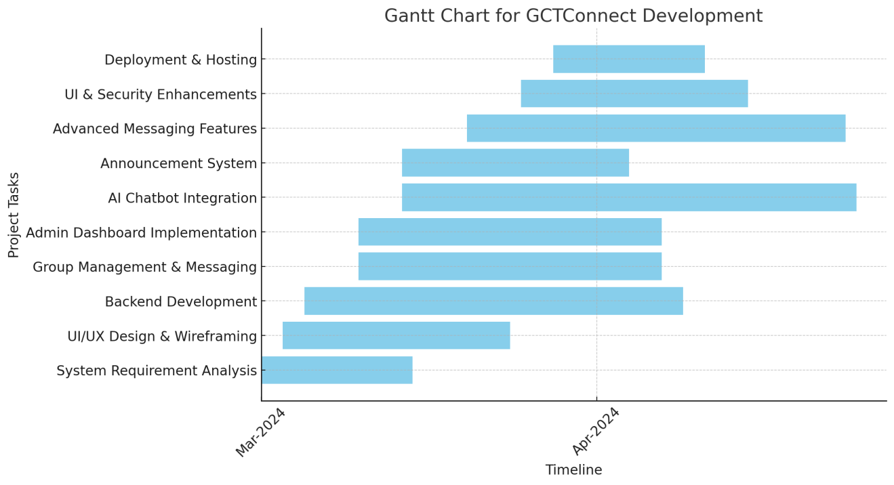

### ****Understanding the Gantt Chart Elements****

**Tasks** are listed **vertically** on the left-hand side.  
 **Time (Weeks)** is shown **horizontally** along the top.  
 **Bars** indicate when each task **starts and ends**.  
 **Overlapping bars** represent tasks that run **simultaneously**.

This chart ensures that **all tasks are completed on schedule**, helping developers and stakeholders **track progress efficiently**.

# ****1.6 Introduction to Team Members and Their Skill Set****

Given that our **project team consists of three members**, each member plays a **crucial role** in ensuring the **successful development and deployment** of **GCTConnect**. The following is an **introduction** to each team member, highlighting their **roles, responsibilities, and relevant expertise**.

## ****Team Lead & Back-End Developer: Talha Mahboob****

### ****Role:****

Talha Mahboob serves as the **Team Lead** and is also responsible for developing the **back-end, database management, deployment, and overall project management**.

### ****Responsibilities:****

**Team Leadership:**

* As the **Team Lead**, Talha **oversees the entire project**, ensuring that all tasks are **aligned with the timeline and objectives**.
* He **coordinates the efforts** of all team members, facilitates **communication**, and **resolves technical or project-related issues**.

**Back-End Development:**

* Talha is responsible for designing and implementing the **server-side logic** of **GCTConnect**.
* This includes **developing APIs, managing server infrastructure, and ensuring efficient data processing**.

**Database Management:**

* Talha designs and maintains the **database system** required for the project.
* He ensures **data integrity, security, and performance** and handles tasks such as **database schema design, query optimization, and maintenance**.

**Deployment & Management:**

* Responsible for **deploying the application** on a server (either **cloud-based or on-premise**).
* Ensures **system uptime, security configurations, and server management** to keep the platform **operational and scalable**.

## ****Front-End Developer & UI/UX Designer: Malik Awais****

### ****Role:****

Malik Awais is responsible for designing and developing the **front-end** of **GCTConnect**, ensuring an **intuitive and user-friendly interface**.

### ****Responsibilities:****

**UI/UX Design:**

* Conducts **user research** to understand the needs and behaviors of the **target audience**.
* Designs **wireframes, mockups, and user interfaces** that are both **functional and visually appealing**.

**Front-End Development:**

* Implements **UI designs using modern front-end technologies** such as **HTML, CSS, JavaScript, and jQuery**.
* Ensures that the **interface is responsive, accessible, and optimized** for different devices (**desktop, tablet, mobile**).

**User Experience (UX) Enhancement:**

* Ensures the system is **easy to use and accessible** for all user groups.
* Gathers **user feedback** and continuously **improves UI designs** based on **testing and user interactions**.

**Collaboration with Back-End:**

* Works closely with the **backend developer (Talha Mahboob)** to integrate **front-end and back-end functionalities seamlessly**.
* Collaborates with the team to ensure the **overall design vision** is **executed accurately**.

## ****Database, Testing & Documentation Specialist: Abdul Majid****

### ****Role:****

Abdul Majid is responsible for the **database management, testing, and documentation** of **GCTConnect**, ensuring that the system **meets all requirements and is free of defects**.

### ****Responsibilities:****

**Database Development & Optimization:**

* Designs and manages the **relational database (SQL Server)** used in the system.
* Ensures **efficient query execution, structured data storage, and normalization techniques** to enhance performance.

**System Testing & Quality Assurance:**

* Develops and executes **test plans and test cases** to ensure the system functions **correctly** and meets all specifications.
* Performs both **manual and automated testing** to identify and report defects.

**Documentation:**

* Creates and maintains **detailed documentation** for all aspects of the project, including:
  + **Requirements documentation**
  + **Database schemas & ER diagrams**
  + **User manuals & technical guides**
  + **Testing reports & bug tracking**
* Ensures that all documentation is **clear, accurate, and up-to-date**.

**Collaboration:**

* Works closely with **both front-end and back-end developers** to understand project requirements.
* Ensures that all **documentation and testing efforts** are aligned with project goals.
* Provides **feedback and suggestions** for improvements based on **testing results**.

The **team members of GCTConnect** work collaboratively to ensure that the project is **successfully developed, tested, and deployed**.

**Talha Mahboob (Team Lead & Backend Developer):** Manages the project, backend development, database, and deployment.  
 **Malik Awais (Frontend Developer & UI/UX Designer):** Develops the front-end, ensuring an intuitive and user-friendly experience.  
 **Abdul Majid (Database, Testing & Documentation):** Manages the database, performs testing, and maintains documentation.

With a **structured division of responsibilities**, the team ensures **efficient workflow, seamless integration of components, and a high-quality final product**. 🚀

# ****1.7 Tools and Technology with Reasoning****

To ensure **efficient development, scalability, and security** in **GCTConnect**, we have chosen a **set of modern tools and technologies** that align with the **project’s requirements**. Each tool and technology serves a **specific purpose**, and the selection is based on factors like **performance, security, compatibility, and ease of development**.

## ****1.7.1 Backend Development****

### ****1. ASP.NET 8 MVC & Web API****

**Reasoning:**

* **MVC (Model-View-Controller) pattern** ensures **modular and scalable** application design.
* **Web API integration** allows seamless communication between **frontend and backend**.
* **High performance & security features** make it **ideal for enterprise applications**.
* **Microsoft ecosystem compatibility** ensures **long-term support and reliability**.

### ****2. C# (C-Sharp)****

**Reasoning:**

* Provides a **robust and structured** programming model.
* Offers **better security features** compared to scripting languages.
* **Optimized for high-performance web applications** and works seamlessly with **ASP.NET**.
* **Strong community support** and **continuous updates**.

## ****1.7.2 Frontend Development****

### ****3. HTML, CSS, JavaScript, jQuery****

**Reasoning:**

* **HTML & CSS** provide a **structured and responsive UI design**.
* **JavaScript & jQuery** enhance **user interactivity** with dynamic elements.
* **Ensures compatibility with all modern browsers**.
* **Lightweight & fast-loading pages**, improving user experience.

## ****1.7.3 Database Management****

### ****4. Microsoft SQL Server****

**Reasoning:**

* **Relational database management system (RDBMS)** ensures **structured data storage**.
* Supports **ACID (Atomicity, Consistency, Isolation, Durability) properties** for **data integrity**.
* **Scalable and optimized for large datasets**, ensuring fast query execution.
* **Built-in security features** protect sensitive user data.

## ****1.7.4 Real-Time Communication****

### ****5. SignalR (Real-Time Messaging)****

**Reasoning:**

* Enables **real-time messaging and notifications**.
* Provides **bi-directional communication between server and client**.
* Reduces **latency** and improves user experience in **group messaging**.
* **Highly scalable** for large institutions like colleges.

## ****1.7.5 AI-Powered Features****

### ****6. AI Chatbot (Natural Language Processing - NLP)****

**Reasoning:**

* Helps students and faculty with **academic queries, admission details, and event schedules**.
* Uses **NLP (Natural Language Processing)** to provide **intelligent responses**.
* Reduces the **workload of administrative staff** by automating frequently asked questions (FAQs).

## ****1.7.6 Version Control & Collaboration****

### ****7. GitHub (Version Control & Code Management)****

**Reasoning:**

* Enables **collaborative development** with version control.
* Ensures **safe and secure code storage**.
* Provides **branching features for testing and merging code efficiently**.
* Helps in **tracking changes, debugging, and issue resolution**.

## ****1.7.7 Development & Debugging Tools****

### ****8. Microsoft Visual Studio 2022 Community Edition****

**Reasoning:**

* **Integrated Development Environment (IDE)** for **ASP.NET, C#, and SQL Server**.
* Offers **powerful debugging tools** for identifying and resolving errors.
* Provides **built-in database management** for easier development.
* **Supports multiple extensions** for enhanced productivity.

## ****1.7.8 Deployment & Hosting****

### ****9. Cloud-Based or On-Premise Hosting****

**Reasoning:**

* Ensures **24/7 availability of GCTConnect** for students and faculty.
* Provides **automatic scaling & backups** to prevent data loss.
* Supports **secure data transmission and encryption**.

# ****1.8 Vision Document for GCTConnect****

## ****1. Introduction****

**GCTConnect** is a **social networking and communication platform** designed specifically for **Government Graduate College Township, Lahore**. The primary vision of this project is to **streamline communication** among students, teachers, HODs, and higher management by providing an **automated, structured, and secure** platform.

Currently, the **college relies on WhatsApp groups**, which results in **manual group creation, miscommunication, and inefficient message delivery**. **GCTConnect eliminates these challenges** by offering:  
 **Automated user registration & role-based group management**  
 **Real-time messaging & announcement system**  
 **AI-powered chatbot for academic queries**  
 **Structured & scalable communication framework**

## ****2. Problem Statement****

### ****Current Challenges in College Communication:****

1. **Manual WhatsApp group creation:** Leads to **errors, missing members, and inefficiencies**.
2. **Hierarchical message forwarding:** **Important announcements** take time to reach students.
3. **Lack of structured messaging:** **No central platform** for students, teachers, and administration.
4. **No AI-based academic assistance:** Students rely on **faculty members for frequently asked queries**.
5. **Limited control & security:** **No institutional control over shared messages and group access**.

## ****3. Product Vision****

The vision of **GCTConnect** is to:  
 **Provide a centralized digital platform** for structured communication.  
 **Eliminate manual group management** by introducing **automated group assignments** based on roles (students, teachers, HODs, principal).  
 **Enhance engagement** through **real-time chat, direct messaging, and announcement notifications**.  
 **Enable AI-driven academic support** with a **smart chatbot** to assist students with queries.  
 **Ensure security & privacy** with **role-based access control and encrypted messaging**.

## ****4. Key Features & Functional Scope****

### ****Phase 1: Core System Development****

**User Registration & Authentication:** Admin registers users and assigns roles (students, teachers, HODs, principal).  
 **Automated Group Creation:** Users are automatically assigned to **role-based chat groups**.  
 **Messaging & Announcements:** Students, teachers, and HODs can send messages, while the principal/admin can send official announcements.  
 **Admin Dashboard:** Allows **user management, group control, and communication monitoring**.

### ****Phase 2: AI Chatbot Integration****

**AI-Powered Academic Assistance:** Provides **real-time responses** to admission inquiries, event details, and academic FAQs.  
 **Automated Information Retrieval:** Fetches data from **college announcements, academic calendars, and official notifications**.

### ****Phase 3: Advanced Features & Deployment****

**Enhanced Messaging System:**

* **Direct messaging between users**
* **Custom group creation**  
   **User Profile Management:** Students and faculty can **update personal information, upload profile pictures, and manage account settings**.  
   **Security Enhancements:** Implementing **data encryption, authentication protocols, and system monitoring**.  
   **Final Deployment:** Hosting the system on a **cloud-based or on-premise college server**.

## ****5. Stakeholders & Users****

### ****Primary Users:****

1. **Students:** Engage in group discussions, view announcements, chat with teachers, and interact with the AI chatbot.
2. **Teachers & HODs:** Communicate with students, manage academic discussions, and send announcements.
3. **Principal & Admin:** Oversee communication, manage users, and send institution-wide notifications.

### ****Key Stakeholders:****

**College Administration:** Ensures the system aligns with institutional communication policies.  
 **IT Department:** Manages **server hosting, security, and system updates**.  
 **Faculty & Students:** Use the platform daily for **academic discussions & collaboration**.

## ****6. Benefits & Expected Outcomes****

**Efficient & Structured Communication:** Eliminates **manual group creation errors** and ensures **real-time message delivery**.  
 **AI-Based Academic Support:** Reduces faculty workload by providing **automated responses** to student queries.  
 **Security & Privacy:** Ensures **role-based access control, encrypted data transmission, and institutional oversight**.  
 **Scalability & Flexibility:** Allows **future enhancements**, such as **learning management system (LMS) integration**.

**GCTConnect is a modern, scalable, and secure communication platform** tailored for **Government Graduate College Township, Lahore**. By integrating **automated group management, AI-driven academic support, and real-time messaging**, it ensures **seamless, efficient, and structured communication** across the college.

This system will **replace inefficient WhatsApp groups**, ensuring that **students, faculty, and administration** have a **centralized, role-based, and AI-powered** communication platform. 🚀

# ****1.9 Risk List****

While **GCTConnect** aims to **streamline communication and collaboration** within **Government Graduate College Township, Lahore**, it also introduces **potential risks** that need to be addressed. Below is a breakdown of key risks and their possible impacts on the system.

### ****1. Data Security Risks****

**Risk:** GCTConnect stores **sensitive user information**, including **names, emails, phone numbers, and role-based data (students, teachers, administrators)**. **Unauthorized access or data breaches** can expose this information, leading to **privacy violations and reputational damage**.

**Mitigation Strategy:**

* **Implement encryption** for sensitive data in **transit and at rest**.
* **Use role-based access control (RBAC)** to **restrict unauthorized data access**.
* **Regular security audits and penetration testing** to identify vulnerabilities.

### ****2. System Outages & Downtime****

**Risk:** **Server failures, software bugs, or cyberattacks** could **disrupt messaging, announcements, and AI chatbot responses**. If the system is unavailable, **students and faculty may face communication breakdowns**, delaying important academic activities.

**Mitigation Strategy:**

* **Cloud-based or redundant server hosting** to ensure **high availability**.
* **Automated system monitoring** to detect and resolve performance issues.
* **Scheduled backups and disaster recovery planning** to **restore services quickly**.

### ****3. Integration Issues****

**Risk:** The system may need to integrate with **existing databases or institutional platforms**. Data inconsistencies, compatibility issues, or API failures could **lead to incorrect user information** and **functional failures**.

**Mitigation Strategy:**

* **Thorough testing of API connections** before deployment.
* **Data validation mechanisms** to prevent incorrect entries.
* **Regular synchronization with external systems** to ensure consistency.

### ****4. Inaccurate Information****

**Risk:** Human errors during **data entry or system misconfiguration** can result in **miscommunication** (e.g., students missing announcements or incorrect group assignments).

**Mitigation Strategy:**

* **Validation checks on user inputs** to reduce data entry errors.
* **Admin approval system** for critical announcements and role assignments.
* **Audit logs** to track changes and identify **incorrect modifications**.

### ****5. Bias in AI Chatbot Responses****

**Risk:** If the AI chatbot is not **trained properly**, it might provide **biased responses** or **incorrect academic guidance**. This could mislead students or **cause unequal treatment in information dissemination**.

**Mitigation Strategy:**

* **Use diverse training datasets** to minimize bias.
* **Regular chatbot updates and feedback mechanisms** to improve response accuracy.
* **Human oversight in chatbot decision-making** for sensitive queries.

### ****6. Denial-of-Service (DoS) Attacks****

**Risk:** Malicious actors might **flood the system with automated requests**, causing **slowdowns or crashes**, disrupting **announcements, messaging, and chatbot interactions**.

**Mitigation Strategy:**

* **Implement rate limiting** to prevent excessive system requests.
* **Use DDoS protection mechanisms** provided by hosting providers.
* **Monitor traffic patterns** to detect suspicious activity early.

### ****7. Insider Threats****

**Risk:** **Unauthorized modifications or misuse of admin privileges** could lead to **manipulation of messages, deletion of important data, or unauthorized access to user accounts**.

**Mitigation Strategy:**

* **Implement multi-factor authentication (MFA)** for admin accounts.
* **Restrict privileges using role-based access control (RBAC)**.
* **Maintain logs of all admin actions** to detect suspicious behavior.

### ****8. User Resistance & Adoption Challenges****

**Risk:** **Students and faculty members may be hesitant** to switch from **existing WhatsApp groups** to GCTConnect due to **habitual use and reluctance to change**.

**Mitigation Strategy:**

* **Conduct awareness sessions and training** for faculty and students.
* **Provide a seamless onboarding experience** with **step-by-step tutorials**.
* **Ensure a user-friendly UI** that feels **intuitive and similar to existing platforms**.

To ensure **GCTConnect remains a secure, efficient, and reliable platform**, we must address these **potential risks** through **proactive security measures, system audits, user training, and continuous monitoring**.

By implementing **robust data protection, server reliability mechanisms, AI fairness checks, and access control policies**, we can **minimize these risks** and ensure **successful adoption and operation of GCTConnect**.

**Important Diagrams**

## ****Use Case DiagramIntroduction****

The **Use Case Diagram** for **GCTConnect** illustrates the **interactions between different user roles** and their respective **tasks within the system**. This diagram provides a **clear visualization of role-based access and functionality**, ensuring that each **user type has defined privileges and actions**.

## ****User Roles & Their Responsibilities****

### ****1. Admin****

**The Admin is responsible for managing users, groups, and system settings.**

* **User Registration (UC1):** The **Admin** registers users (students, teachers, HODs, and the principal) in the system.
* **Login & Authentication (UC2):** The Admin logs in to manage platform functionalities.
* **Create & Delete Groups (UC3):** The Admin can **automatically or manually** create and delete groups based on departments, batches, and faculty.
* **Create & Delete Batches (UC4):** The Admin has the ability to create or remove student batches.
* **Manage User Roles (UC8):** The Admin assigns user roles (e.g., student, teacher, HOD, principal) and **grants permissions** accordingly.

**Importance:** The Admin acts as the **primary controller** of user access and system configurations.

### ****2. Principal****

**The Principal has administrative privileges but focuses on high-level announcements and monitoring.**

* **Login & Authentication (UC2):** The Principal logs in to access the platform.
* **View Announcements (UC6):** The Principal can view official college-wide announcements.
* **Post Announcements (UC9):** The Principal can send **official announcements** to students, teachers, and HODs.

**Importance:** The Principal ensures that important updates and college-wide communications are **delivered effectively**.

### ****3. Head of Department (HOD)****

**HODs play a managerial role within their respective departments.**

* **Login & Authentication (UC2):** HODs log in to access their department’s communication and announcements.
* **Create & Delete Groups (UC3):** HODs can create departmental discussion groups for faculty and students.
* **Send Messages (UC5):** HODs can send important messages within their assigned department.
* **View Announcements (UC6):** HODs receive college-wide and department-specific announcements.
* **Post Announcements (UC9):** HODs can post announcements for their department.

🔹 **Importance:** The HOD ensures that **departmental communication remains structured and effective**.

### ****4. Teacher****

**Teachers communicate with students, share academic discussions, and view institutional updates.**

* **Login & Authentication (UC2):** Teachers log in to access student discussions and course-related groups.
* **Send Messages (UC5):** Teachers communicate with students in subject-based or batch-specific groups.
* **View Announcements (UC6):** Teachers can read important institutional and department-level announcements.

**Importance:** Teachers facilitate **student engagement** by maintaining **active communication channels**.

### ****5. Student****

**Students are the primary users, interacting with peers, faculty, and the AI chatbot.**

* **Login & Authentication (UC2):** Students log in to access their communication groups.
* **Send Messages (UC5):** Students can participate in discussions within their assigned groups.
* **View Announcements (UC6):** Students receive updates from teachers, HODs, and the principal.
* **AI Chatbot Queries (UC7):** Students can interact with the AI chatbot to get **academic and college-related information (e.g., admissions, event schedules, FAQs).**

**Importance:** Students **actively engage with the system** for communication, academic discussions, and quick AI-powered assistance.

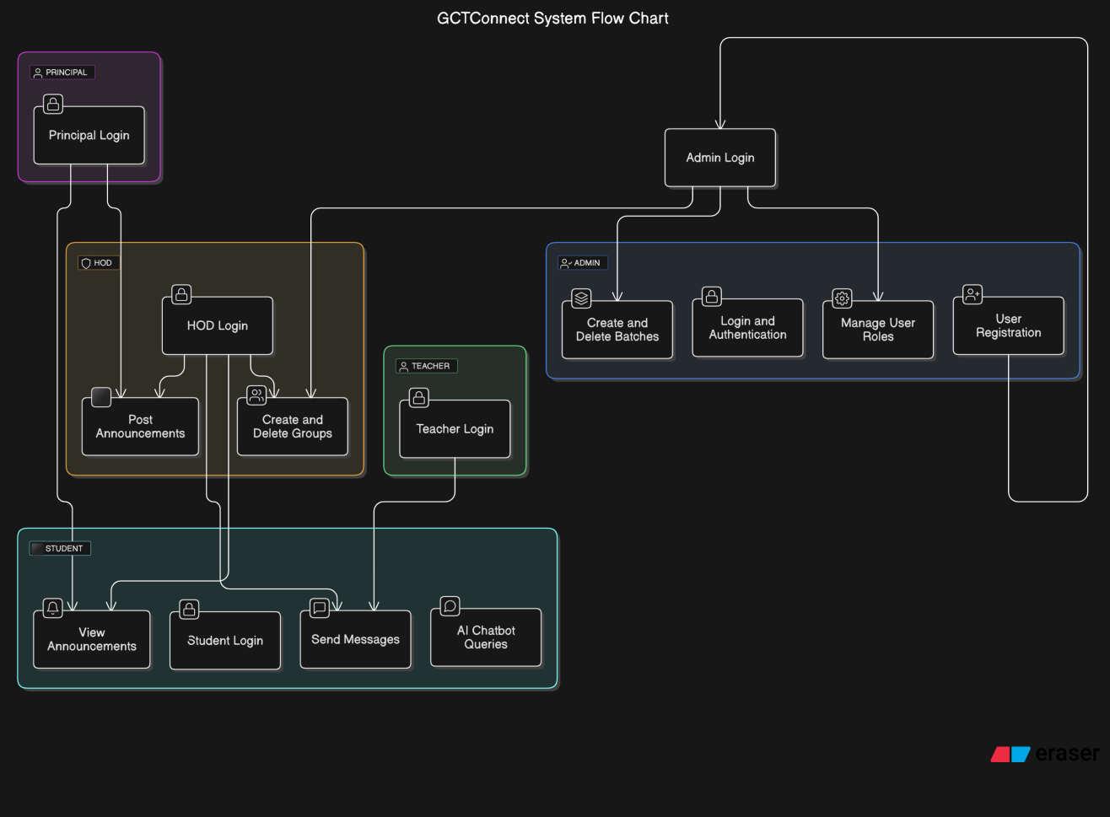

1. ****Sequence Diagram:****

## ****1. Sequence Diagram for User Registration & Login****

### ****Actors Involved:****

User (Admin, Principal, HOD, Teacher, Student)  
 System (GCTConnect)

### ****Flow of Events:****

1. **User initiates registration** (Admin registers a new user).
2. **System verifies & creates user credentials** (stores user data in the database).
3. **System sends login credentials via email**.
4. **User enters username & password for login**.
5. **System validates credentials** and **grants access** based on the role (Admin, Student, Teacher, etc.).
6. **User is redirected to the dashboard** based on their role.

## ****2. Sequence Diagram for Automated Group Assignment****

### ****Actors Involved:****

Admin (Initiates process)  
 System (Handles automation)  
 User (Student, Teacher, HOD)

### ****Flow of Events:****

1. **Admin registers new users** (Students, Teachers, HODs).
2. **System automatically assigns users to relevant groups** based on:
   1. **Students → Assigned to batch & department groups**.
   2. **Teachers → Assigned to department groups**.
   3. **HODs → Assigned to department-wide faculty groups**.
3. **System updates group membership database**.
4. **Users receive notification about group assignments**.

## ****3. Sequence Diagram for Sending Messages in a Group****

### ****Actors Involved:****

User (Student, Teacher, HOD, Principal)  
 System (Handles message delivery)  
 Group Members (Receivers)

### ****Flow of Events:****

1. **User selects a group and types a message**.
2. **System checks sender’s role and permissions**.
3. **System sends the message to all group members**.
4. **All recipients receive a notification of the new message**.
5. **Users can view and reply to messages in real time**.

## ****4. Sequence Diagram for AI Chatbot Query****

### ****Actors Involved:****

Student (User)  
 AI Chatbot  
 Database

### ****Flow of Events:****

1. **Student types a question in the chatbot** (e.g., “When are the final exams?”).
2. **System (Chatbot) processes the query** using **Natural Language Processing (NLP)**.
3. **Chatbot retrieves relevant information** from the **college database** (e.g., exam schedules, admissions, event dates).
4. **Chatbot sends the response to the student**.
5. **Student receives the answer in chat format**.

## ****5. Sequence Diagram for Announcement System****

### ****Actors Involved:****

Principal / Admin / HOD (Announcement Sender)  
 System (Stores and delivers announcements)  
 Recipients (All relevant users)

### ****Flow of Events:****

1. **Principal/Admin/HOD creates a new announcement**.
2. **System processes and categorizes the announcement** (college-wide, department-specific, batch-specific).
3. **System delivers announcements to relevant users** (Students, Teachers, HODs).
4. **Users receive notifications about the announcement**.
5. **Users can view the announcement in the system dashboard**.

## ****6. Sequence Diagram for Creating & Managing Groups****

### ****Actors Involved:****

Admin / HOD  
 System (Manages group creation and membership)  
 Users (Students, Teachers, HODs)

### ****Flow of Events:****

1. **Admin/HOD selects group creation option**.
2. **System prompts for group details (Name, Type, Members)**.
3. **Admin/HOD enters group information** and confirms.
4. **System creates the group and assigns members**.
5. **Users receive notifications about group assignments**.
6. **Group members can start discussions**.

## ****7. Sequence Diagram for Batch Creation & Management****

### ****Actors Involved:****

Admin  
 System (Handles batch assignment)  
 Students (Assigned users)

### ****Flow of Events:****

1. **Admin selects “Create Batch” option**.
2. **Admin enters batch details (Department, Year, Students)**.
3. **System creates the batch and assigns students**.
4. **Students receive notifications about their batch allocation**.
5. **Students are automatically added to batch-specific groups**.

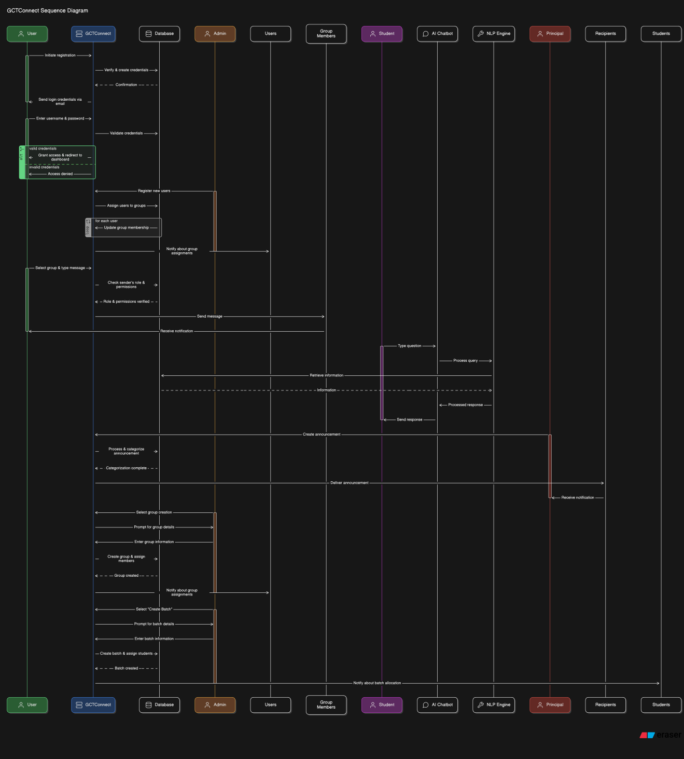

### ****3. Flowchart for GCTConnect:****

A **flowchart** represents the **workflow of the system**, showing the step-by-step process of how users interact with GCTConnect and how the system handles different functionalities. Below is an overview of the **flowchart structure** for GCTConnect.

## ****1. Main Components of the Flowchart****

The **GCTConnect flowchart** consists of the following major components:

**User Registration & Authentication**

* 1. Admin registers new users (students, teachers, HODs, principal).
  2. System verifies user details and assigns appropriate roles.
  3. Users log in using their credentials.
  4. If credentials are correct → Redirect to role-specific dashboard.
  5. If incorrect → Show error message.

**Automated Group & Batch Assignment**

* 1. System assigns users to predefined groups based on **role and department**.
  2. Students get assigned to **batch and department groups**.
  3. Teachers and HODs are grouped based on **subjects and departments**.
  4. Notifications are sent to users about their assigned groups.

**Messaging & Communication**

* 1. User selects a **group chat**.
  2. System **verifies role permissions** (students can only send messages; admins can manage groups).
  3. If permitted → Message is sent.
  4. System **delivers message to group members**.

**AI Chatbot Query Processing**

* 1. Student asks a question (e.g., “What is the admission deadline?”).
  2. Chatbot processes the query and retrieves information from the **college database**.
  3. AI Chatbot responds with the required information.
  4. Student receives an answer in the chat interface.

**Announcements & Notifications**

* 1. Principal, Admin, or HOD creates an **announcement**.
  2. System **categorizes** the announcement as:
     1. College-wide
     2. Department-specific
     3. Batch-specific
  3. Announcement is delivered to relevant users.
  4. Users receive notifications.

**Group & Batch Management**

* 1. Admin or HOD **creates, updates, or deletes** groups and batches.
  2. System assigns students and faculty members accordingly.
  3. System notifies users about group/batch changes.

**User Logout**

* 1. User clicks the logout button.
  2. System ends the session and redirects to the login page.

## ****2. Flowchart Representation****

The **GCTConnect Flowchart** can be represented as follows:

1️⃣ **Start**  
2️⃣ **User Registration & Login Process**  
3️⃣ **Automated Group & Batch Assignment**  
4️⃣ **Messaging & Chat System**  
5️⃣ **AI Chatbot Interaction**  
6️⃣ **Announcements & Notifications**  
7️⃣ **Group & Batch Management**  
8️⃣ **Logout & End Session**

Each of these steps has **decision points** (e.g., login validation, role verification, permission checking) that guide the system’s behavior.

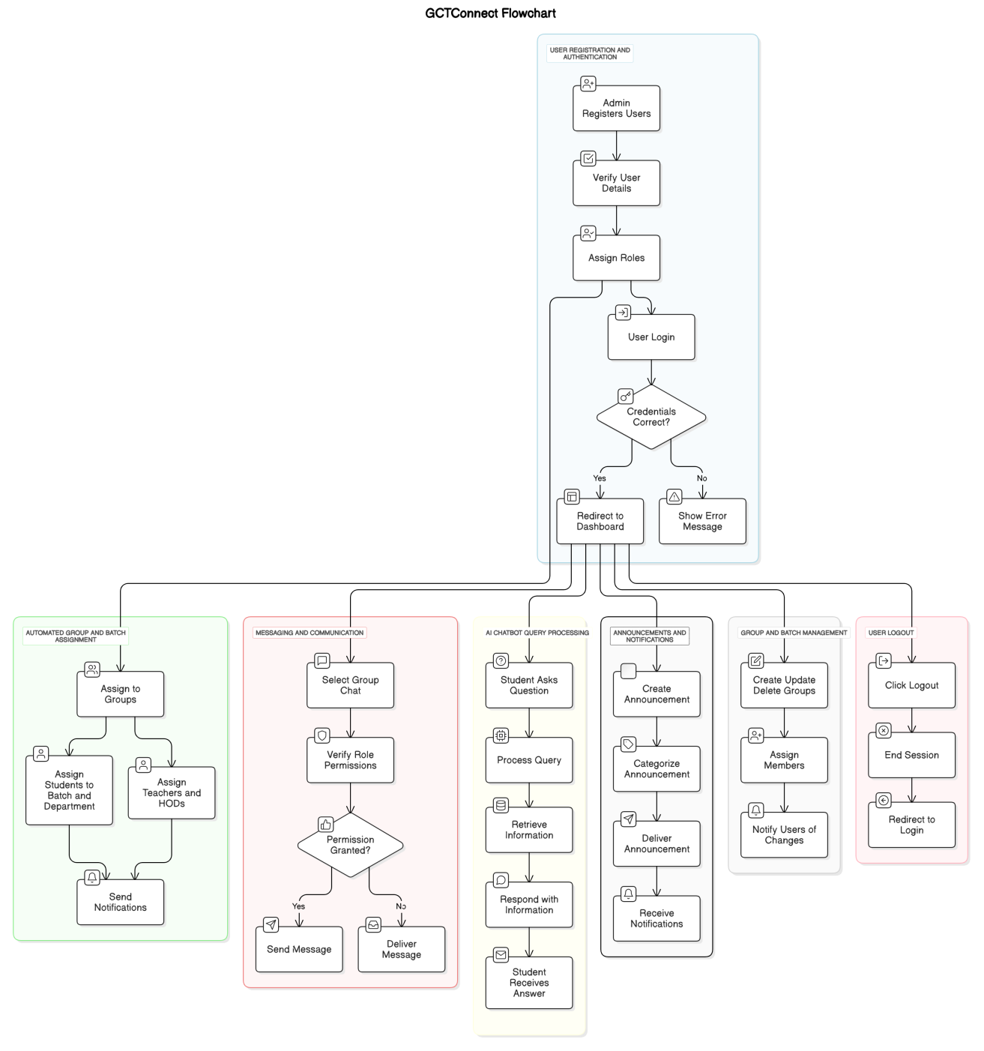

### **4. **Class Diagram for GCTConnect****

A **class diagram** represents the **static structure of the system**, defining the **classes, attributes, methods, and relationships** between them. The **GCTConnect class diagram** helps visualize **how different components interact** and how data flows between them.

### ****1. Key Classes in GCTConnect****

**User Class**

* **Attributes:** user_id, username, password, email, phone_number, role, department_id, batch_id
* **Methods:** login(), logout(), updateProfile()

**Admin Class (Inherits from User)**

* **Methods:** createUser(), deleteUser(), manageRoles(), createBatch(), deleteBatch(), createGroup(), deleteGroup()

**Principal Class (Inherits from User)**

* **Methods:** postAnnouncement(), viewUsers(), approveChanges()

**HOD Class (Inherits from User)**

* **Methods:** createGroup(), deleteGroup(), postAnnouncement(), manageFaculty()

**Teacher Class (Inherits from User)**

* **Methods:** sendMessage(), viewAnnouncements(), joinGroup()

**Student Class (Inherits from User)**

* **Methods:** sendMessage(), viewAnnouncements(), askChatbotQuery()

**Group Class**

* **Attributes:** group_id, group_name, description, created_by, department_id
* **Methods:** addMember(), removeMember(), sendMessage(), deleteGroup()

**Message Class**

* **Attributes:** message_id, sender_id, group_id, content, timestamp
* **Methods:** sendMessage(), editMessage(), deleteMessage()

**Announcement Class**

* **Attributes:** announcement_id, title, content, created_by, timestamp, target_audience
* **Methods:** createAnnouncement(), deleteAnnouncement(), editAnnouncement()

**Chatbot Class**

* **Attributes:** query_id, user_id, query_text, response, timestamp
* **Methods:** processQuery(), fetchResponse(), logQuery()

**Database Class**

* **Methods:** storeData(), retrieveData(), updateData(), deleteData()

### ****2. Relationships Between Classes****

* **User → Admin, Principal, HOD, Teacher, Student (Inheritance Relationship)**
* **User has a Relationship with Group (A user can be part of multiple groups)**
* **Group contains Messages (Aggregation: Messages belong to groups)**
* **Principal/Admin/HOD can create Announcements (Association Relationship)**
* **Students interact with the AI Chatbot (Association Relationship)**
* **Database stores all Entities (Dependency Relationship)**

### ****3. Considerations for Class Diagram****

* **Use proper inheritance for role-based users** (Admin, Principal, HOD, Teacher, Student inherit from User).
* **Relationships should be clearly defined** (e.g., one-to-many between users and groups).
* **CRUD operations (Create, Read, Update, Delete) should be defined for relevant classes** (Announcements, Messages, Groups).
* **Include data security methods** in the Database class to prevent unauthorized access.

### ****4. Benefits of the Class Diagram****

* **Helps developers understand the object-oriented structure of GCTConnect**.
* **Defines clear relationships between classes** to avoid redundancy.
* **Improves maintainability by defining reusable components**.
* **Ensures security by separating user roles and permissions**.

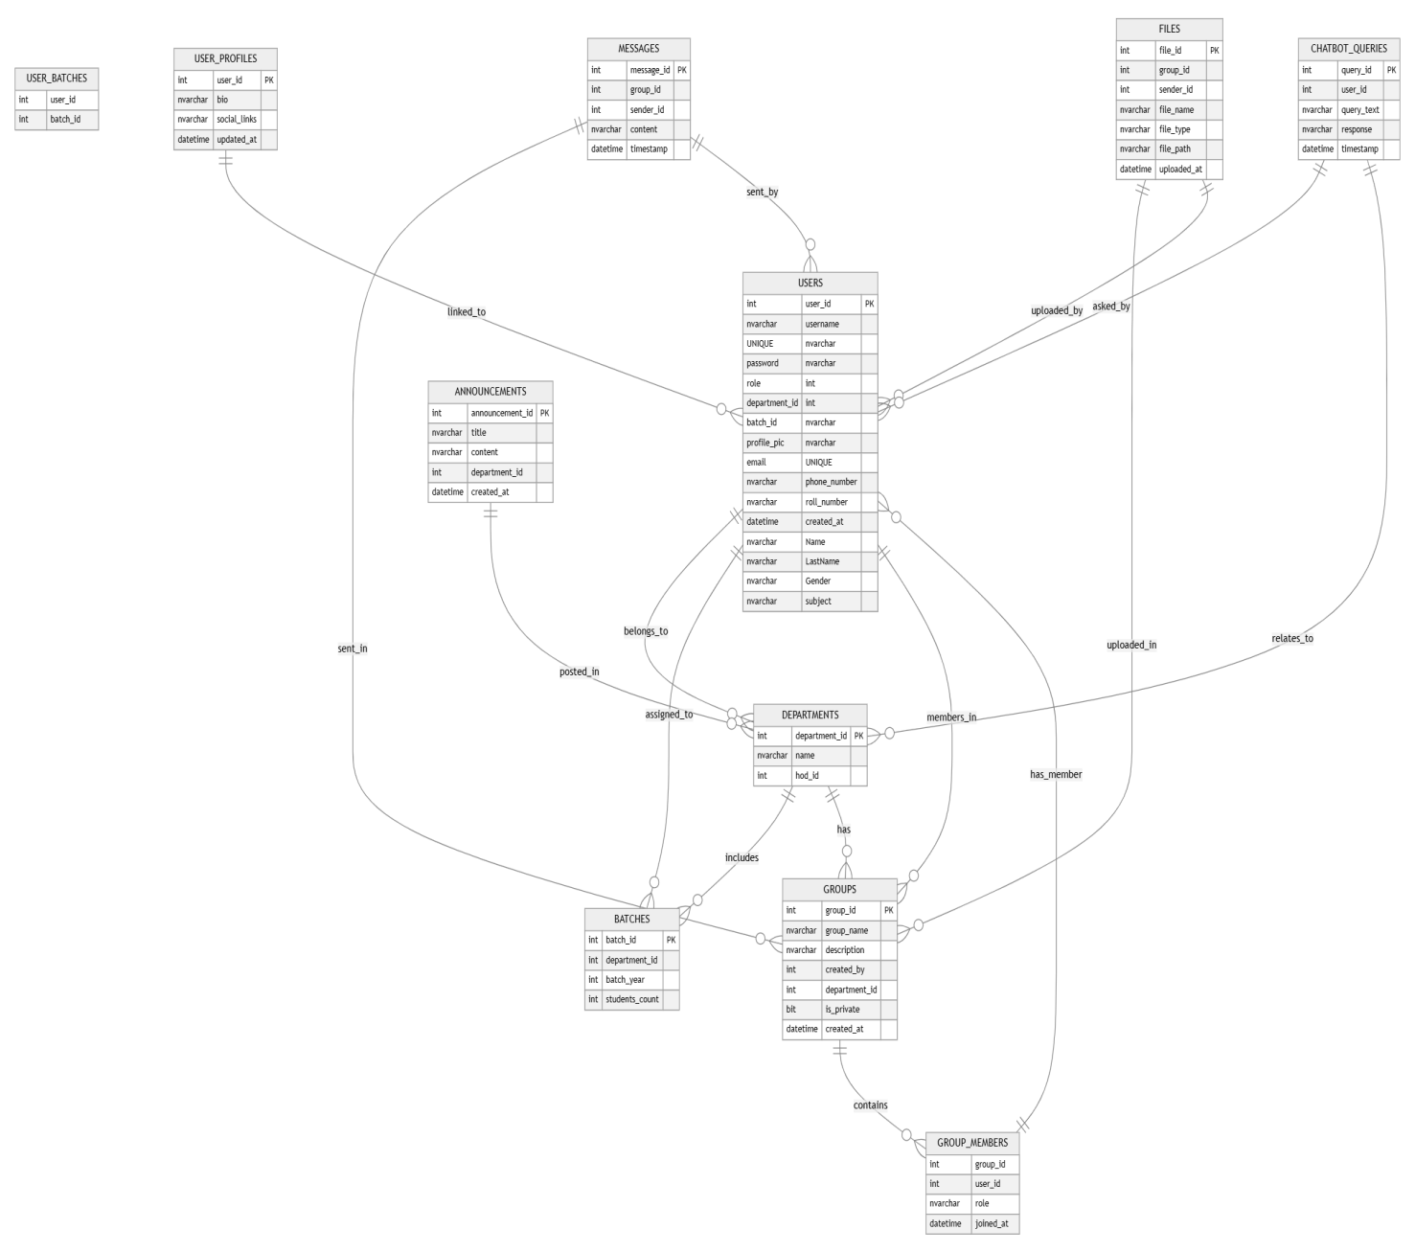

### ****5.Entity-Relationship (ER) Diagram for GCTConnect****

An **ER Diagram** represents the **database structure** of **GCTConnect**, showing **entities, attributes, and relationships** between different components. This helps in **designing a well-structured relational database**.

### ****1. Key Entities in GCTConnect****

#### ****User Entity****

* **Attributes:** user_id (Primary Key), username, password, email, phone_number, role, department_id (Foreign Key), batch_id (Foreign Key)
* **Relationships:**
  + A **User can belong to multiple Groups** (User_Group association).
  + A **User can send Messages**.
  + A **User can create Announcements** (Admin, HOD, Principal).
  + A **User can interact with the AI Chatbot**.

#### ****Admin Entity (Subtype of User)****

* **Responsibilities:** Manages Users, Groups, and Batches.
* **Attributes:** Inherits from User.

#### ****Principal Entity (Subtype of User)****

* **Responsibilities:** Posts Announcements and Monitors User Activity.
* **Attributes:** Inherits from User.

#### ****HOD Entity (Subtype of User)****

* **Responsibilities:** Manages Faculty and Groups.
* **Attributes:** Inherits from User.

#### ****Teacher Entity (Subtype of User)****

* **Responsibilities:** Sends Messages, Views Announcements.
* **Attributes:** Inherits from User.

#### ****Student Entity (Subtype of User)****

* **Responsibilities:** Sends Messages, Asks Chatbot Queries, Views Announcements.
* **Attributes:** Inherits from User.

### ****2. Supporting Entities****

#### ****Group Entity****

* **Attributes:** group_id (Primary Key), group_name, description, created_by (Foreign Key to User)
* **Relationships:**
  + A **Group contains multiple Users**.
  + A **Group contains multiple Messages**.

#### ****Message Entity****

* **Attributes:** message_id (Primary Key), sender_id (Foreign Key to User), group_id (Foreign Key to Group), content, timestamp
* **Relationships:**
  + A **Message belongs to a Group**.
  + A **Message is sent by a User**.

#### ****Announcement Entity****

* **Attributes:** announcement_id (Primary Key), title, content, created_by (Foreign Key to User), timestamp, target_audience
* **Relationships:**
  + An **Announcement is created by an Admin, Principal, or HOD**.
  + An **Announcement is visible to multiple Users**.

#### ****Batch Entity****

* **Attributes:** batch_id (Primary Key), batch_year, department_id (Foreign Key to Department), students_count
* **Relationships:**
  + A **Batch belongs to a Department**.
  + A **Batch contains multiple Students**.

#### ****Department Entity****

* **Attributes:** department_id (Primary Key), name, hod_id (Foreign Key to User)
* **Relationships:**
  + A **Department has a Head (HOD)**.
  + A **Department contains multiple Batches**.
  + A **Department contains multiple Teachers and Students**.

#### ****Chatbot Query Entity****

* **Attributes:** query_id (Primary Key), user_id (Foreign Key to User), query_text, response, timestamp
* **Relationships:**
  + A **Chatbot Query is created by a Student**.
  + The **AI Chatbot processes and responds**.

### ****3. Relationships Between Entities****

**One-to-Many:**

* + One **User** can **send multiple Messages**.
  + One **Group** can **contain multiple Messages**.
  + One **Announcement** can **be seen by multiple Users**.
  + One **Department** has **multiple Students and Teachers**.
  + One **Batch** has **multiple Students**.

**Many-to-Many (With Bridging Tables):**

* + A **User can be in multiple Groups** (Handled via User_Group table).
  + A **User can receive multiple Announcements** (Handled via User_Announcements table).

### ****4. Considerations for ER Diagram****

* **Primary Keys (PK) should be unique** for each entity (e.g., user_id, group_id, message_id).
* **Foreign Keys (FK) should establish relationships** between entities (e.g., group_id in Message refers to Group).
* **Normalization should be followed** to remove redundancy (e.g., separating Users and Roles into subtypes).
* **Security should be ensured** by encrypting sensitive data such as passwords.

### ****5. Benefits of the ER Diagram****

* **Clearly defines database relationships** for developers.
* **Helps in efficient query execution and database optimization**.
* **Ensures data consistency by following normalization principles**.
* **Provides a strong foundation for system architecture and API development**.

Would you like me to generate a **graphical ER Diagram** based on this structure? 🚀

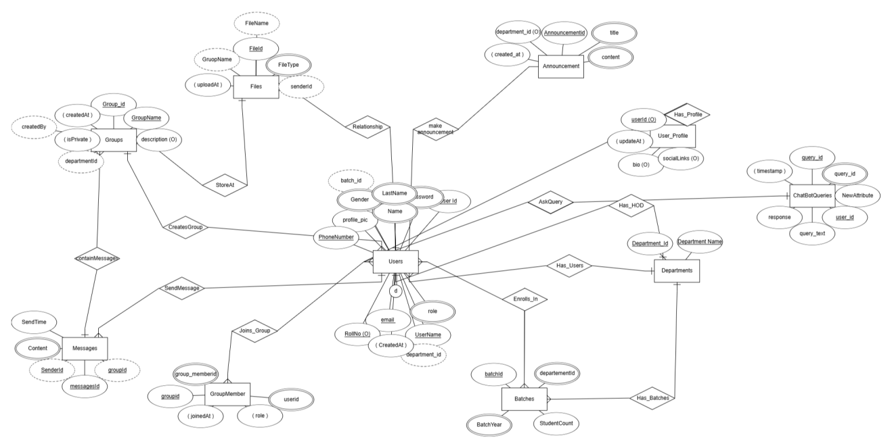

### 

### 

### **Summary**

The **System Design** chapter provided a structured overview of the key design ideas, refinements, and critical decisions made during the development of **GCTConnect**. The chapter highlighted the **three-tier architecture**, which ensures **modularity, scalability, and maintainability** by separating the **presentation layer (frontend), business logic layer (backend), and data layer (database).**

The **object-oriented design (OOD) principles** and **MVC pattern** were adopted to enhance **code reusability, scalability, and separation of concerns.** The **database design followed 3rd Normal Form (3NF)** to minimize redundancy and ensure **data integrity through constraints and relationships** such as **role-based access control, batch and department mapping, and student roll number uniqueness.**

Security was a top priority, leading to the implementation of **role-based access control (RBAC), password hashing, encrypted communication, and SQL injection prevention.** Additionally, **AI chatbot integration using Natural Language Processing (NLP)** was designed to assist students and faculty with **automated responses for queries related to admissions, schedules, and announcements.**

Several algorithmic choices were made to optimize system performance, such as **batch creation & deletion automation using SQL triggers and stored procedures, and SignalR for real-time messaging.** These choices improved efficiency and automated various administrative processes.

The design choices in **GCTConnect** align with the project’s objectives of **improving academic communication, automating user and group management, integrating AI assistance, and enhancing overall system security.** The refined system architecture and database design **provide a scalable and efficient solution for institutional networking.**

This chapter plays a crucial role in ensuring that the system is **technically sound, efficient, and capable of meeting user expectations while supporting future enhancements.** 🚀

### **References**

#### **1. Architectural Design & Object-Oriented Design**

Gamma, E., Helm, R., Johnson, R., & Vlissides, J. (1994). *Design Patterns: Elements of Reusable Object-Oriented Software*. Addison-Wesley.

Buschmann, F., Meunier, R., Rohnert, H., Sommerlad, P., & Stal, M. (1996). *Pattern-Oriented Software Architecture: A System of Patterns*. Wiley.

Fowler, M. (2002). *Patterns of Enterprise Application Architecture*. Addison-Wesley.

#### **2. Database Design & Normalization**

Codd, E. F. (1970). "A relational model of data for large shared data banks." *Communications of the ACM, 13*(6), 377-387.

Silberschatz, A., Korth, H. F., & Sudarshan, S. (2019). *Database System Concepts* (7th ed.). McGraw-Hill.

Elmasri, R., & Navathe, S. B. (2017). *Fundamentals of Database Systems* (7th ed.). Pearson.

#### **3. Security & Authentication**

Viega, J., & McGraw, G. (2001). *Building Secure Software: How to Avoid Security Problems the Right Way*. Addison-Wesley.

OWASP Foundation. (2021). *OWASP Top Ten 2021: The Ten Most Critical Web Application Security Risks*. Retrieved from <https://owasp.org/www-project-top-ten/>

Bishop, M. (2005). *Introduction to Computer Security*. Addison-Wesley.

#### **4. AI Chatbot & Natural Language Processing (NLP)**

Russell, S. J., & Norvig, P. (2021). *Artificial Intelligence: A Modern Approach* (4th ed.). Pearson.

Jurafsky, D., & Martin, J. H. (2021). *Speech and Language Processing* (3rd ed.). Pearson.

IBM Watson. (2020). "AI-Powered Chatbots in Education." Retrieved from https://www.ibm.com/cloud/watson-assistant

#### **5. Messaging System & SignalR Implementation**

* Microsoft Docs. (2023). *ASP.NET Core SignalR: Build Real-time Web Apps*. Retrieved from<https://docs.microsoft.com/en-us/aspnet/core/signalr/>
* Troelsen, A., & Japikse, P. (2021). *Pro C# 9 with .NET 5: Foundational Principles and Practices in Programming*. Apress.

#### **6. Software Engineering & System Design Principles**

* Sommerville, I. (2015). *Software Engineering* (10th ed.). Pearson.

Pressman, R. S. (2019). *Software Engineering: A Practitioner’s Approach* (9th ed.). McGraw-Hill.

IEEE. (1998). *IEEE Standard 1016-1998: IEEE Recommended Practice for Software Design Descriptions*. Retrieved from<https://ieeexplore.ieee.org/>

#### **7. Web Development Technologies (ASP.NET, C#, SQL Server)**

Freeman, A. (2021). *Pro ASP.NET Core 6 MVC*. Apress.

Esposito, D. (2020). *Modern Web Development with ASP.NET Core 3: An Architect’s Guide*. Microsoft Press.

Microsoft Docs. (2023). *ASP.NET Core Documentation*. Retrieved from<https://docs.microsoft.com/en-us/aspnet/core/>

#### **8. Project Documentation & UML Modeling (Sequence Diagram)**

Rumbaugh, J., Booch, G., & Jacobson, I. (2004). *The Unified Modeling Language Reference Manual* (2nd ed.). Addison-Wesley.

Larman, C. (2011). *Applying UML and Patterns: An Introduction to Object-Oriented Analysis and Design and Iterative Development* (3rd ed.). Pearson.